Organisation name: Estonian Non-destructive Testing Board (Estonian Aviation Academy)
Mittepurustavate katsete nõukogu (Lennuakadeemia)
Requirement: Standard EVS-EN 4179:2021
Yes - In compliance;
No – Non-conformity;
N/A - Not applicable;
N/R – Not reviewed
Reference to a requirement |  | Result | Comment
C.2.1 | A NANDTB is an independent national aerospace organization representing a nation’s aerospace industry and is recognized by the nation’s Regulatory Agency to provide or support NDT qualification services iaw standard EN 4179. | Yes | All aviation industry is presented: Magnetic MRO AS, Aeroskills OÜ.  Not yet recognized because of initial assessment.
C.2.2 | Each NANDTB shall define, organize, administer and manage activities iaw standard EN 4179. | Yes | NANDTB's activities are based on the standard
C.2.3 | NANDTB shall have a written constitution, deciding entity and be governed according to administrative and working procedures and shall issue statue or similar document containing:  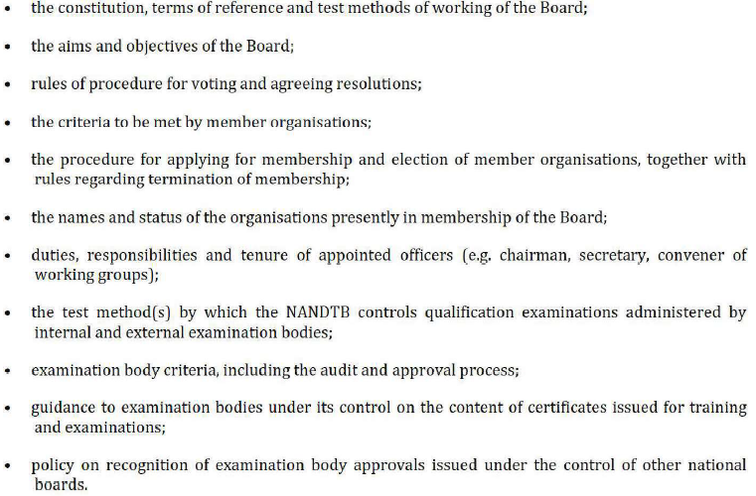 | Yes | Estonian Aviation Academy Non-Destructive Testing Board of estonia  Statutes Rev. 0, 27.01.2025
C.2.4 | As a minimum, the voting members in the deciding entity shall be Level 3 personnel from design, production and/or maintenance organisations that are approved by the nation’s regulatory agency. Other members may be co-opted as voting or non-voting members as necessary to support the activities of the NANDTB. | Yes | Statues Ch. 3.3.1
C.2.5 | Regulatory agencies for civilian and/or defence have the right to be included as observer members of the NANDTB. | Yes | Statues Ch. 3.3.2
C.2.6 | Each NANDTB shall disclose on a public forum e.g. on a website:  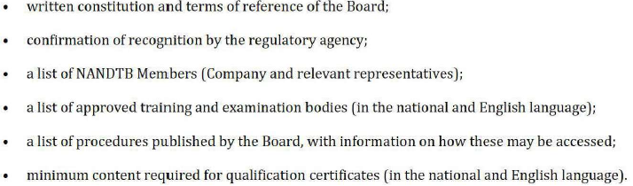 |  | https://lennuakadeemia.ee/arendus-koostoo/vorgustumine
C.2.7 | Applicable NANDTB procedures shall be available for review /audit by the employer’s customers and regulatory agencies. | Yes | All required documents, procedures, etc. were submitted.
C.2.8 | The employer’s Responsible Level 3 may use an NDTB to:  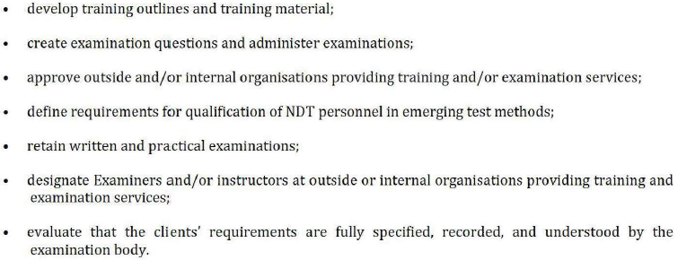 | Yes | Implemented.
C.2.9 | If an NANDTB is used to provide training and/or examinations, it shall be treated as an outside agency and the employer’s Responsible Level 3 shall verify that the training and/or examinations meet the employer’s requirements. | N/A | NDTB Estonia does not provide NDT training and/or examinations.
C.2.10 |  | N/A
C.2.11 | For emerging NDT methods, where the applicable NANDTB has a process for qualifying the first Level 3 in new NDT method, this process shall be used. | N/A
C.3.1 | 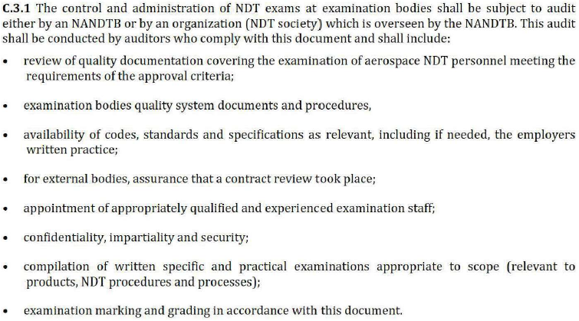 | C | Present and Suitable  Chapter 6
C.3.2 | Outside Agencies under the control of a NANDTB may be recognized by formal approval of NANDTB’s and/or organizations in other countries where the controlling NANDTB complies with the minimum requirements of standard EN 4179 and is a member of the Aerospace NDT Board Forum. | N/A | NDTB Estonia is not a member of the Aerospace NDT Board Forum.
C.4 | Record retention.  When an NANDTB is used, the scores for the latest written and practical examinations shall be kept by the employer but actual examinations may be kept by the NANDTB. All such records, except for actual examinations, shall be made available to the applicable employee upon request or upon leaving the company for any reason. | N/R | No records during establishment

Auditors names: Ivo Tolga
Margus Keerman
Date: 14.02.2025

